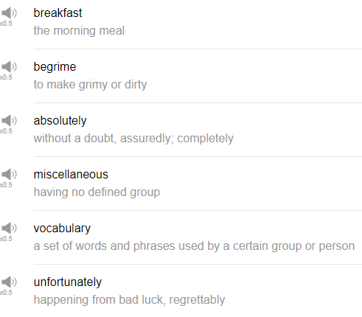

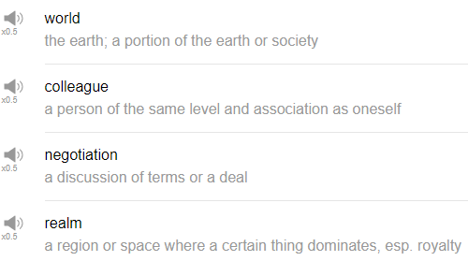

|  |
| --- |
| Hi, everybody my name is Alisha and today we're going to be talking about ten of the hardest words to pronounce according to you guys. So we collected some information from you on Facebook, thanks very much for sending in your ideas, and these are the top 10 most difficult words for you to pronounce. So let's get started! |
| Absolutely. |
| Absolutely might be tough to pronounce. Absolutely means 100%. Absolutely is an agreement phrase. Are you going to that music event next week? Absolutely. Yes, 100%, definitely. Absolutely. lute like a lute, LUTE. |
| Begrime. |
| Begrime apparently means dirty, I've never heard nor use this word before, but perhaps it's difficult to pronounce. Begrime. The door to my apartment was begrimed in the storm last week. |
| Breakfast. |
| The next word is breakfast. Breakfast is hard to pronounce, but that is the meaning of breakfast. You're breaking the fast, so fast is a period of time without eating, and to break means to, well in this case, breaking something it doesn't refer to, like, crushing a think, but stopping something, to break the fast of the night, in other word. So you're fasting during the night, you're not eating, so you wake up in the morning you break the fast. But we don't say "break fast," we say breakfast. In a sentence, this morning for breakfast I ate a bowl of cereal with grapes, and I had a coffee too. |
| Colleague. |
| Yes, colleague, many of my students struggle with this, they say coLLEAgue, or they say calleaGUE or something because the spelling of this world is really really strange, there's that GUE at the end. Or more commonly I feel just co-worker, colleagues sounds slightly more formal to me than co-worker. Somebody who you work with, or somebody who you have a business relationship with, in some sense. Could be a person from another company, could be somebody from your own company. Anyone who you do business dealings with is your colleague, can be your colleague. In a sentence, I'm going to a networking event with my colleagues next week. |
| Miscellaneous. |
| That MISC, miscellaneous, so it's just the spelling I think maybe it's confusing for this word, miscellaneous. Miscellaneous just means other stuff, or just other uncategorized stuff. I keep a lot of miscellaneous items in a drawer in my house. Maybe they don't really fit into one category like it's not kitchen thing, it's not clothing, it's just sort of a mixture of things, miscellaneous things. |
| Negotiation. |
| The next word is negotiation. Negotiation. yeah there are two T's in this, but neither T is a hard T, they're both very soft that "sh-sh" sound, because they're followed by the "i" and another vowel, the TIA, negotiation. Negotiation refers to a compromise between two people, you're trying to make a decision and you negotiate. In this case, it's the noun form, negotiation. Business negotiations continued for more than a month with this important deal. |
| Realm. |
| I see why this one's hard, because of that REALM part, the of EALM, it's a weird word isn't it did you talk about. Just like the kind of a fantasy world, a sort of the nuances of this phrase the realm. In a sentence, let us go to the realm where the elves live and eat their bread. |
| Unfortunately. |
| The next word is unfortunately. Unfortunately. Unfortunately just means too bad. you can use this to to start bad news, for example, unfortunately I can't come to work today because I'm sick. Or unfortunately I broke my arm at the basketball game last week. Or unfortunately my haircut is bad. |
| Vocabulary. |
| Vocabulary just refers to the words in a language. My vocabulary in my second language is really really low. I need a bigger vocabulary so that I can express myself more clearly. |
| World. |
| Ah I see why this one's hard. World, world. Hard to pronounce that RLD, I think together is tough, plus that W at the beginning as well. Such a short word but you have to say so many weird things the same time. World, your tongue is going like this. In a sentence, I have traveled all over the world and the best food is in... my stomach. |
| That's the end! So those are 10 hard to pronounce words. Give them a try slowly at first and just gonna try to work up to saying it at a more natural speed if you like. Thank you so much for sharing your opinions with us on Facebook, and please make sure to subscribe to our channel so you don't miss out on any of this fun information. So thanks again for watching today and we'll see you again next time, bye! |
| You don't need new shoes you need new feet. |